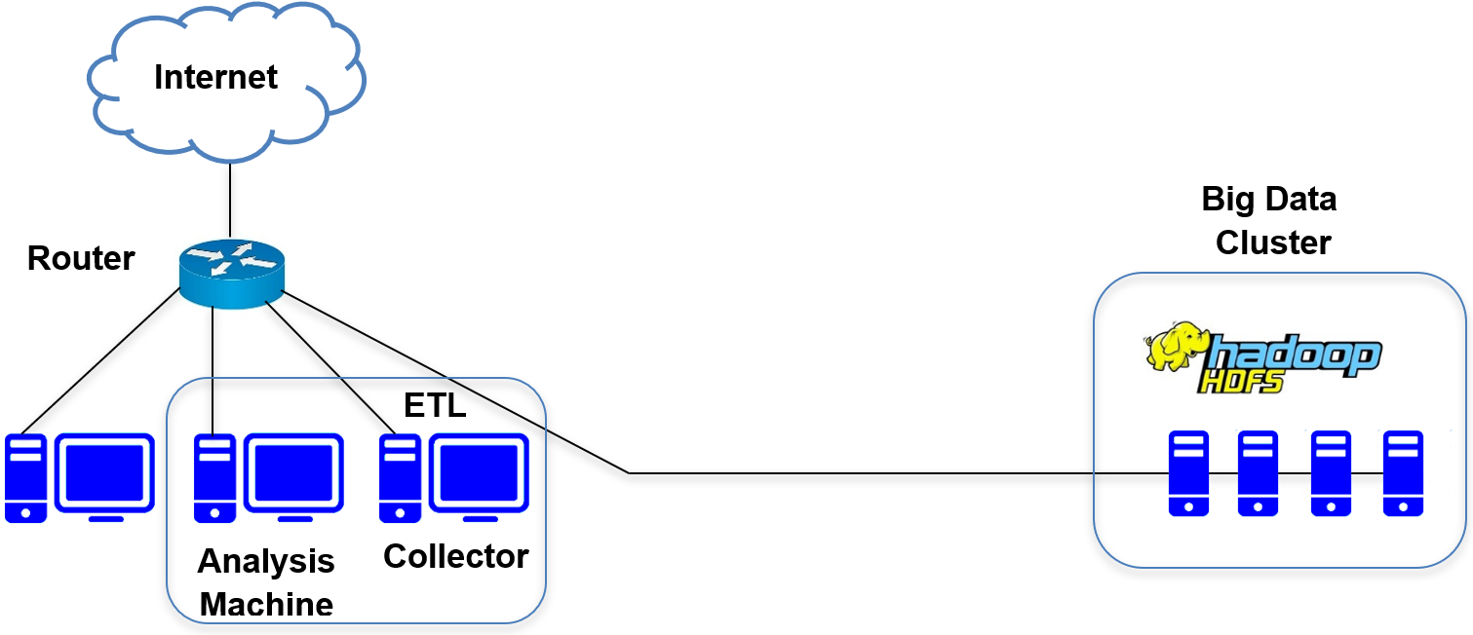

Figure 1. Big Data and Machine Learning architecture for intrusion detection

Figure 2. Classification accuracy of two classes, five classes and twenty-three classes

Number of nodes | 2 classes | 5 classes | 23 classes
1 | 1826 | 1856,5 | 1792,8
2 | 1823,1 | 1797,6 | 1721,9
3 | 1820,6 | 1784,1 | 1704,1
4 | 1672,6 | 1660,1 | 1670,9
5 | 1667,6 | 1611,9 | 1659,4

Number of nodes | 2 classes | 5 classes | 23 classes
1 | 742,06 | 637,13 | 499,77
2 | 716,69 | 555,57 | 490,62
3 | 691,56 | 538,59 | 467,98
4 | 536,57 | 488,49 | 451,24
5 | 516,52 | 447,63 | 446,39

Number of nodes | 2 classes | 5 classes | 23 classes
1 | 57,532 | 60,048 | 104,86
2 | 55,935 | 45,57 | 59,177
3 | 47,545 | 42,687 | 56,096
4 | 46,092 | 42,117 | 51,906
5 | 38,042 | 41,051 | 34,209

Figure 3. The evolution of training and validation time according to the number of nodes in the cluster
(a) KNN, (b) SVM, (c) Tree

